**Batch: A - 2 Roll No.: 16014022050**

**Experiment No.: 5**

|  |
| --- |
| **Title: To implement Predictive Modeling using linear regression.** |

**Aim:** **Prediction using linear regression model, model assessment and improving the model.**

______________________________________________________________________

**Expected Outcome of Experiment:**

____________________________________________________________________

**Books/ Journals/ Websites referred:**

1. http://r-statistics.co/Linear-Regression.html
2. https://en.wikipedia.org/wiki/Linear_regression
3. https://machinelearningmastery.com/linear-regression-for-machine-learning/

_____________________________________________________________________

**Pre Lab/ Prior Concepts (Predictive modeling):**

**Linear regression** is a regression model that uses a straight line to describe the relationship between variables. It finds the line of best fit through your data by searching for the value of the regression coefficient(s) that minimizes the total error of the model.

There are two main types of linear regression:

* **Simple linear regression** uses only one independent variable
* **Multiple linear regression**uses two or more independent variables

**Simple linear regression**: The first dataset contains observations about income (in a range of $15k to $75k) and happiness (rated on a scale of 1 to 10) in an imaginary sample of 500 people. The income values are divided by 10,000 to make the income data match the scale of the happiness scores (so a value of $2 represents $20,000, $3 is $30,000, etc.)

**Multiple linear regression**: The second dataset contains observations on the percentage of people biking to work each day, the percentage of people smoking, and the percentage of people with heart disease in an imaginary sample of 500 towns.

**Step by Step explanation of Linear Regression using R**

## Step 1: Load the data into R

Follow these four steps for each dataset:

1. In RStudio, go to File > Import dataset > From Text (base).
2. Choose the data file you have downloaded (income.data or heart.data), and an Import Dataset window pops up.
3. In the Data Frame window, you should see an X (index) column and columns listing the data for each of the variables (income and happiness or biking, smoking, and heart.disease).
4. Click on the Import button and the file should appear in your Environment tab on the upper right side of the RStudio screen.

After you’ve loaded the data, check that it has been read in correctly using summary().

### Simple regression –

summary(income.data)

Because both our variables are [quantitative](https://www.scribbr.com/methodology/types-of-variables/#quantitative-vs-categorical), when we run this function we see a table in our console with a numeric summary of the data. This tells us the minimum, [median](https://www.scribbr.com/statistics/median/), [mean](https://www.scribbr.com/statistics/mean/), and maximum values of the independent variable (income) and dependent variable (happiness):

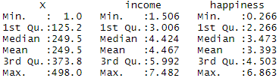

### Multiple regression –

summary(heart.data)

Again, because the variables are quantitative, running the code produces a numeric [summary](https://www.scribbr.com/working-with-sources/how-to-summarize/) of the data for the [independent variables](https://www.scribbr.com/methodology/independent-and-dependent-variables/#independent) (smoking and biking) and the [dependent variable](https://www.scribbr.com/methodology/independent-and-dependent-variables/#dependent) (heart disease):

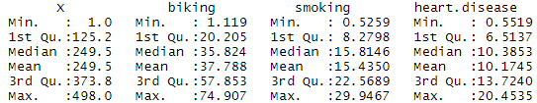

## Step 2: Make sure your data meet the assumptions

We can use R to check that our data meet the four mains [assumptions for linear regression](https://www.scribbr.com/statistics/simple-linear-regression/#assumptions).

### Simple regression –

1. **Independence of observations** (aka no autocorrelation):

Because we only have one independent variable and one dependent variable, we don’t need to test for any hidden relationships among variables.

If you know that you have autocorrelation within variables (i.e. multiple observations of the same test subject), then do not proceed with a simple linear regression! Use a structured model, like a linear mixed-effects model, instead.

1. **Normality:**

To check whether the dependent variable follows a [normal distribution](https://www.scribbr.com/statistics/normal-distribution/), use the hist() function.

hist(income.data$happiness)

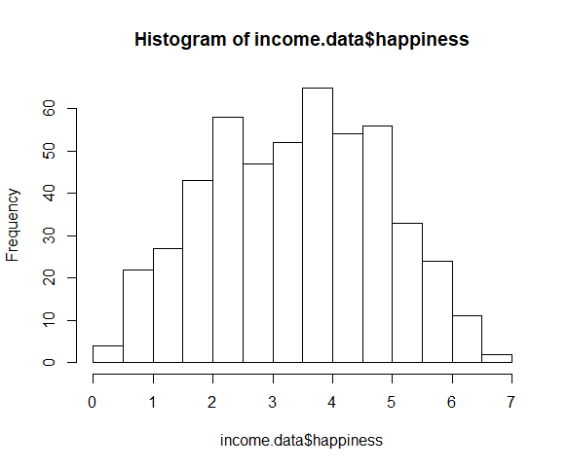

The observations are roughly bell-shaped (more observations in the middle of the distribution, fewer on the tails), so we can proceed with the linear regression.

1. **Linearity:**

The relationship between the independent and dependent variable must be linear. We can test this visually with a scatter plot to see if the distribution of data points could be described with a straight line.

plot(happiness ~ income, data = income.data)

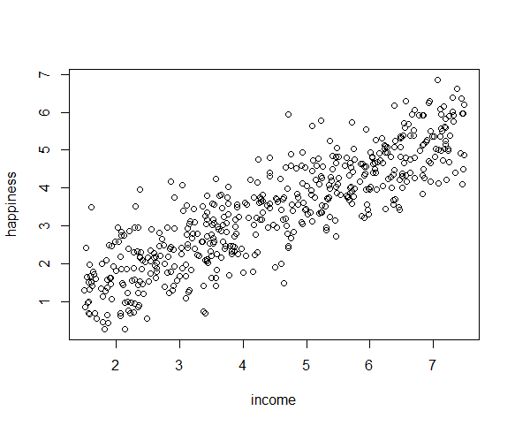

The relationship looks roughly linear, so we can proceed with the linear model.

1. **Homoscedasticity**(aka homogeneity of [variance](https://www.scribbr.com/statistics/variance/)):

This means that the prediction error doesn’t change significantly over the range of prediction of the model. We can test this assumption later, after fitting the linear model.

### Multiple regression –

1. **Independence of observations** (aka no autocorrelation):

Use the cor() function to test the relationship between your independent variables and make sure they aren’t too highly correlated.

cor(heart.data$biking, heart.data$smoking)

When we run this code, the output is 0.015. The [correlation](https://www.scribbr.com/methodology/correlation-vs-causation/) between biking and smoking is small (0.015 is only a 1.5% correlation), so we can include both parameters in our model.

1. **Normality:**

Use the hist() function to test whether your dependent variable follows a [normal distribution](https://www.scribbr.com/statistics/normal-distribution/).

hist(heart.data$heart.disease)

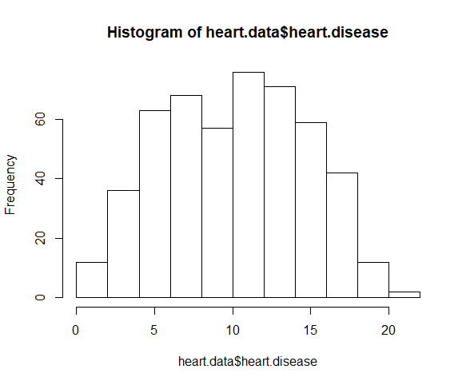

The distribution of observations is roughly bell-shaped, so we can proceed with the linear regression.

1. **Linearity:**

We can check this using two scatterplots: one for biking and heart disease, and one for smoking and heart disease.

plot(heart.disease ~ biking, data=heart.data)

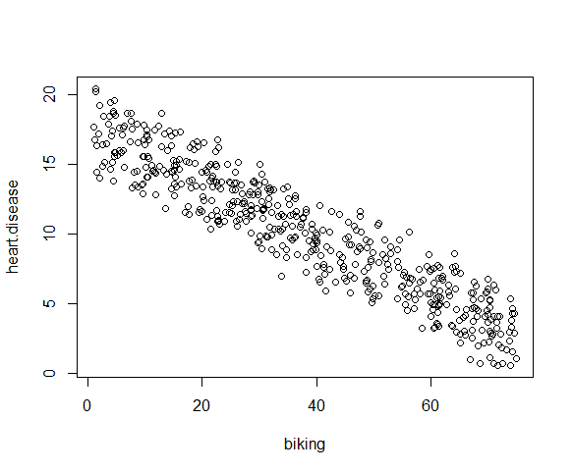

plot(heart.disease ~ smoking, data=heart.data)

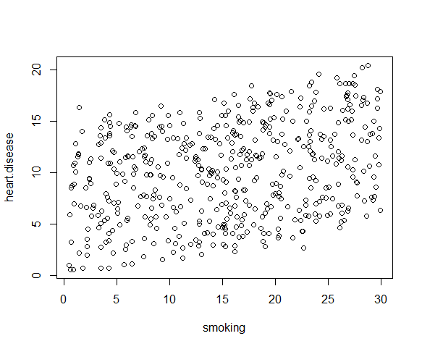

Although the relationship between smoking and heart disease is a bit less clear, it still appears linear. We can proceed with linear regression.

1. **Homoscedasticity:**

We will check this after we make the model.

## Step 3: Perform the linear regression analysis

Now that you’ve determined your data meet the assumptions, you can perform a linear regression analysis to evaluate the relationship between the independent and dependent variables.

### Simple regression: income and happiness –

Let’s see if there’s a linear relationship between income and happiness in our survey of 500 people with incomes ranging from $15k to $75k, where happiness is measured on a scale of 1 to 10.

To perform a simple linear regression analysis and check the results, you need to run two lines of code. The first line of code makes the linear model, and the second line prints out the summary of the model:

income.happiness.lm <- lm(happiness ~ income, data = income.data)

summary(income.happiness.lm)

The output looks like this:

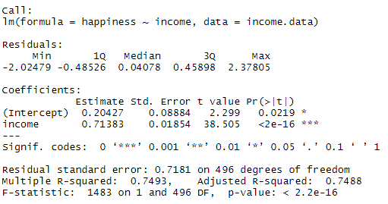

These outputs table first presents the model equation, then summarizes the model residuals (see step 4).

The **Coefficients** section shows:

1. The estimates (**Estimate**) for the model parameters – the value of the y-intercept (in this case 0.204) and the estimated effect of income on happiness (0.713).
2. The[standard error](https://www.scribbr.com/statistics/standard-error/) of the estimated values (**Std. Error**).
3. The [test statistic](https://www.scribbr.com/statistics/test-statistic/) (***t* value**, in this case the [*t*statistic](https://www.scribbr.com/statistics/t-test/)).
4. The [*p*value](https://www.scribbr.com/statistics/p-value/) (**Pr(>| t | )**), aka the probability of finding the given *t* statistic if the [null hypothesis](https://www.scribbr.com/statistics/null-and-alternative-hypotheses/) of no relationship were true.

The final three lines are model diagnostics – the most important thing to note is the ***p*value** (here it is 2.2e-16, or almost zero), which will indicate whether the model fits the data well.

From these results, we can say that there is a **significant positive relationship** between income and happiness (*p*value < 0.001), with a 0.713-unit (+/- 0.01) increase in happiness for every unit increase in income.

### Multiple regression: biking, smoking, and heart disease –

Let’s see if there’s a linear relationship between biking to work, smoking, and heart disease in our imaginary survey of 500 towns. The rates of biking to work range between 1 and 75%, rates of smoking between 0.5 and 30%, and rates of heart disease between 0.5% and 20.5%.

To test the relationship, we first fit a linear model with heart disease as the dependent variable and biking and smoking as the independent variables. Run these two lines of code:

heart.disease.lm<-lm(heart.disease ~ biking + smoking, data = heart.data)

summary(heart.disease.lm)

The output looks like this:

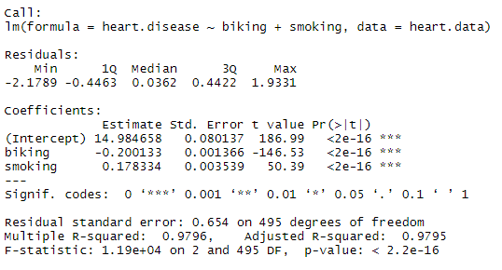

The estimated effect of biking on heart disease is -0.2, while the estimated effect of smoking is 0.178.

This means that for every 1% increase in biking to work, there is a correlated 0.2% decrease in the incidence of heart disease. Meanwhile, for every 1% increase in smoking, there is a 0.178% increase in the rate of heart disease.

The standard errors for these regression coefficients are very small, and the *t* statistics are very large (-147 and 50.4, respectively). The*p*values reflect these small errors and large *t* statistics. For both parameters, there is almost zero probability that this effect is due to chance.

Remember that these data are made up for this example, so in real life these relationships would not be nearly so clear!

## Step 4: Check for Homoscedasticity

Before proceeding with data visualization, we should make sure that our models fit the homoscedasticity assumption of the linear model.

### Simple regression –

We can run plot(income.happiness.lm) to check whether the observed data meets our model assumptions:

par(mfrow=c(2,2))  
plot(income.happiness.lm)  
par(mfrow=c(1,1))

Note that the par(mfrow()) command will divide the Plots window into the number of rows and columns specified in the brackets. So par(mfrow=c(2,2)) divides it up into two rows and two columns. To go back to plotting one graph in the entire window, set the parameters again and replace the (2,2) with (1,1).

These are the residual plots produced by the code:

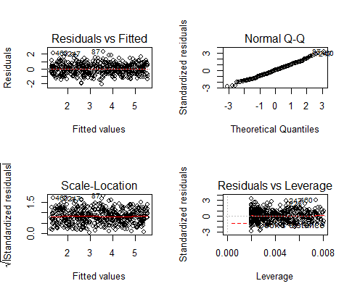

Residuals are the unexplained [variance](https://www.scribbr.com/statistics/variance/). They are not exactly the same as model error, but they are calculated from it, so seeing a bias in the residuals would also indicate a [bias](https://www.scribbr.com/faq-category/research-bias/) in the error.

The most important thing to look for is that the red lines representing the mean of the residuals are all basically horizontal and centered around zero. This means there are no [outliers](https://www.scribbr.com/statistics/outliers/) or biases in the data that would make a linear regression invalid.

In the **Normal Q-Qplot**in the top right, we can see that the real residuals from our model form an almost perfectly one-to-one line with the theoretical residuals from a perfect model.

Based on these residuals, we can say that our model meets the assumption of homoscedasticity.

### Multiple regression –

Again, we should check that our model is actually a good fit for the data, and that we don’t have large variation in the model error, by running this code:

par(mfrow=c(2,2))  
plot(heart.disease.lm)  
par(mfrow=c(1,1))

The output looks like this:

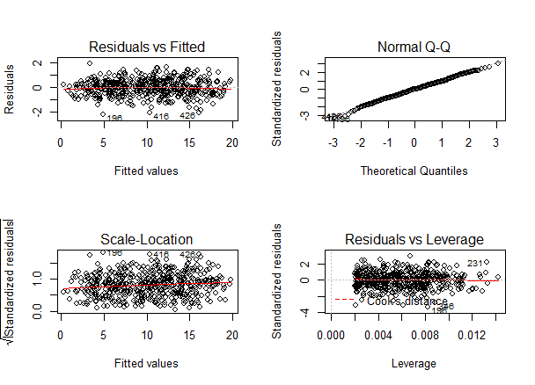

As with our simple regression, the residuals show no bias, so we can say our model fits the assumption of homoscedasticity.

## Step 5: Visualize the results with a graph

Next, we can plot the data and the regression line from our linear regression model so that the results can be shared.

### Simple regression –

Follow 4 steps to visualize the results of your simple linear regression.

1. **Plot the data points on a graph:**

income.graph<-ggplot(income.data, aes(x=income,y=happiness))+geom_point()

income.graph

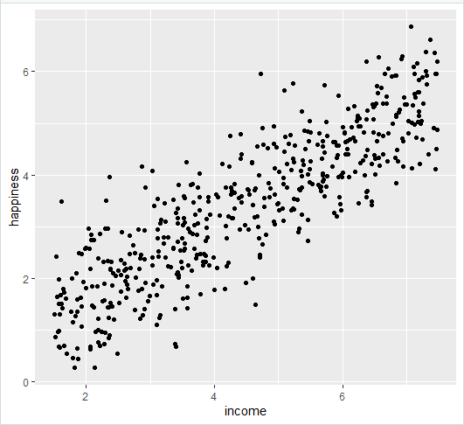

1. **Add the linear regression line to the plotted data:**

Add the regression line using geom_smooth() and typing in lm as your method for creating the line. This will add the line of the linear regression as well as the standard error of the estimate (in this case +/- 0.01) as a light grey stripe surrounding the line:

income.graph <- income.graph + geom_smooth(method="lm", col="black")

income.graph

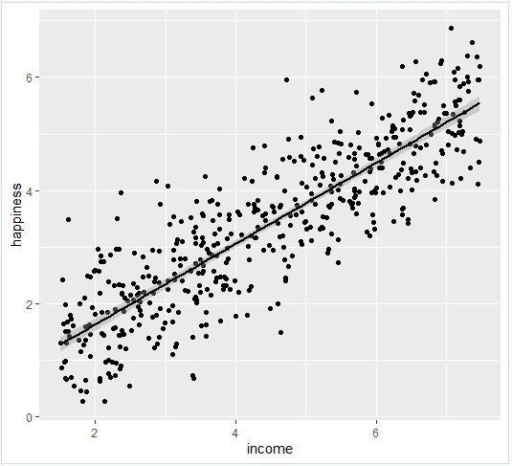

1. **Add the equation for the regression line:**

income.graph <- income.graph + stat_regline_equation(label.x = 3, label.y = 7)

income.graph

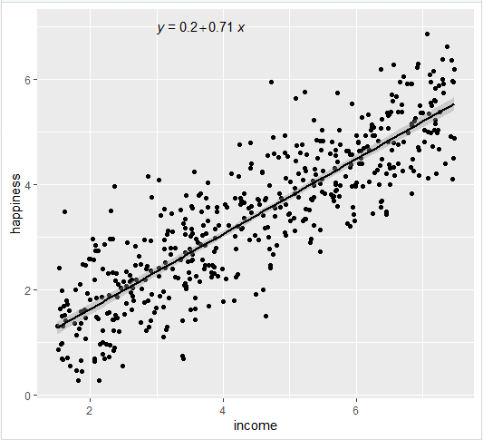

1. **Make the graph ready for publication:**

We can add some style parameters using theme_bw() and making custom [labels](https://www.scribbr.com/us-vs-uk/labelled-or-labeled/) using labs().

income.graph + theme_bw() + labs(title = "Reported happiness as a function of income", x = "Income (x$10,000)", y = "Happiness score (0 to 10)")

This produces the finished graph that you can include in your papers:

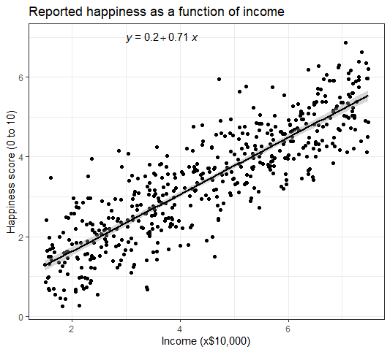

### Multiple regression –

The visualization step for multiple regression is more difficult than for simple regression, because we now have two predictors. One option is to plot a plane, but these are difficult to read and not often published.

We will try a different method: plotting the relationship between biking and heart disease at different levels of smoking. In this example, smoking will be treated as a factor with three levels, just for the purposes of displaying the relationships in our data.

There are 7 steps to follow.

1. **Create a new dataframe with the information needed to plot the model:**

Use the function expand.grid() to create a dataframe with the parameters you supply. Within this function we will:

* Create a sequence from the lowest to the highest value of your observed biking data;
* Choose the minimum, mean, and maximum values of smoking, in order to make 3 levels of smoking over which to predict rates of heart disease.

plotting.data<-expand.grid(biking = seq(min(heart.data$biking), max(heart.data$biking), length.out=30), smoking=c(min(heart.data$smoking), mean(heart.data$smoking), max(heart.data$smoking)))

This will not create anything new in your console, but you should see a new data frame appear in the **Environment** tab. Click on it to view it.

1. **Predict the values of heart disease based on your linear model:**

Next, we will save our ‘predicted y’ values as a new column in the dataset we just created.

plotting.data$predicted.y <- predict.lm(heart.disease.lm, newdata=plotting.data)

1. **Round the smoking numbers to two decimals:**

This will make the legend easier to read later on.

plotting.data$smoking <- round(plotting.data$smoking, digits = 2)

1. **Change the ‘smoking’ variable into a factor:**

This allows us to plot the interaction between biking and heart disease at each of the three levels of smoking we chose.

plotting.data$smoking <- as.factor(plotting.data$smoking)

1. **Plot the original data:**

heart.plot <- ggplot(heart.data, aes(x=biking, y=heart.disease)) + geom_point()

heart.plot

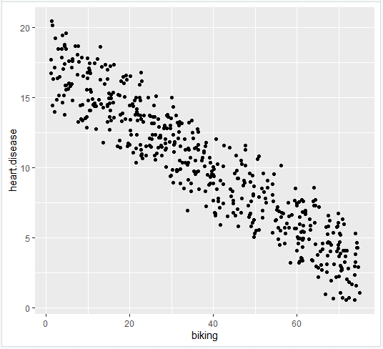

1. **Add the regression lines:**

heart.plot <- heart.plot + geom_line(data=plotting.data, aes(x=biking, y=predicted.y, color=smoking), size=1.25)

heart.plot

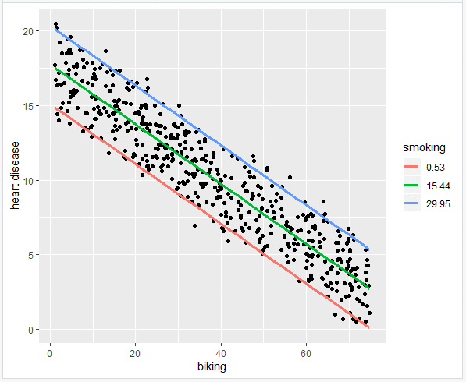

1. **Make the graph ready for publication:**

heart.plot <- heart.plot + theme_bw() + labs(title = "Rates of heart disease (% of population) \n as a function of biking to work and smoking", x = "Biking to work (% of population)", y = "Heart disease (% of population)", color = "Smoking \n (% of population)")

heart.plot

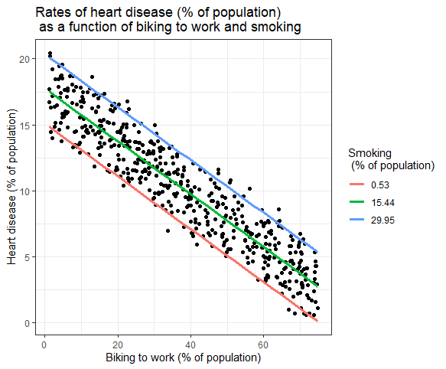

Because this graph has two regression coefficients, the stat_regline_equation() function won’t work here. But if we want to add our regression model to the graph, we can do so like this:

heart.plot + annotate(geom="text", x=30, y=1.75, label=" = 15 + (-0.2*biking) + (0.178*smoking)")

This is the finished graph that you can include in your papers!

## Step 6: Report your results

In addition to the graph, include a brief statement explaining the results of the regression model.

Reporting the results of simple linear regressionWe found a significant relationship between income and happiness (*p* < 0.001, *R*2 = 0.73 ± 0.0193), with a 0.73-unit increase in reported happiness for every $10,000 increase in income.Reporting the results of multiple linear regressionIn our survey of 500 towns, we found significant relationships between the frequency of biking to work and the frequency of heart disease and the frequency of smoking and frequency of heart disease (*p* < 0 and *p* < 0.001, respectively).

Specifically, we found a 0.2% decrease (± 0.0014) in the frequency of heart disease for every 1% increase in biking, and a 0.178% increase (± 0.0035) in the frequency of heart disease for every 1% increase in smoking.

______________________________________________________________________

**Implementation:**

**SIMPLE REGRESSION**

**Rcode Implementation –**

Salary.Data_Simple.Regression <- read.csv("C:/Users/admin/OneDrive/Desktop/sem 4/ADS - Honours/lab/Salary Data_Simple Regression.csv")

View(Salary.Data_Simple.Regression)

summary(Salary.Data_Simple.Regression)

hist(Salary.Data_Simple.Regression$Salary, xlab = ("Salary"), main = ("Histogram of Salary"))

plot(Salary.Data_Simple.Regression$Salary ~ Salary.Data_Simple.Regression$YearsExperience, xlab = ("Years of Experience"), ylab = ("Salary"), main = ("Linear Plot of Experience and Salary"))

lm_model <- lm(Salary ~ YearsExperience, data = Salary.Data_Simple.Regression)

summary(lm_model)

par(mfrow=c(2,2))

plot(lm_model)

par(mfrow=c(1,1))

library(ggplot2)

salary.graph <- ggplot(Salary.Data_Simple.Regression, aes(x = YearsExperience, y = Salary)) +

geom_point()

print(salary.graph)

salary.graph <- ggplot(Salary.Data_Simple.Regression, aes(x = YearsExperience, y = Salary)) +

geom_point() +

geom_smooth(method="lm", col="black")

print(salary.graph)

install.packages("ggpmisc")

#library(ggpmisc)

#salary.graph <- ggplot(Salary.Data_Simple.Regression, aes(x = YearsExperience, y = Salary)) +

#geom_point() +

#geom_smooth(method="lm", col="black") +

#stat_regline_equation(label.x = 3, label.y = 7)

#print(salary.graph)

library(ggplot2)

salary.graph <- ggplot(Salary.Data_Simple.Regression, aes(x = YearsExperience, y = Salary)) +

geom_point() +

geom_smooth(method = "lm", col = "black") +

annotate("text", x = 3, y = 7,

label = paste("y =", round(coef(lm_model)[1], 2), "+",

round(coef(lm_model)[2], 2), "x"))

print(salary.graph)

salary.graph + theme_bw() + labs(title = "Reported Salary as a function of Years of Experience", x = "Years of Experience", y = "Salary")

**Importing dataset –**

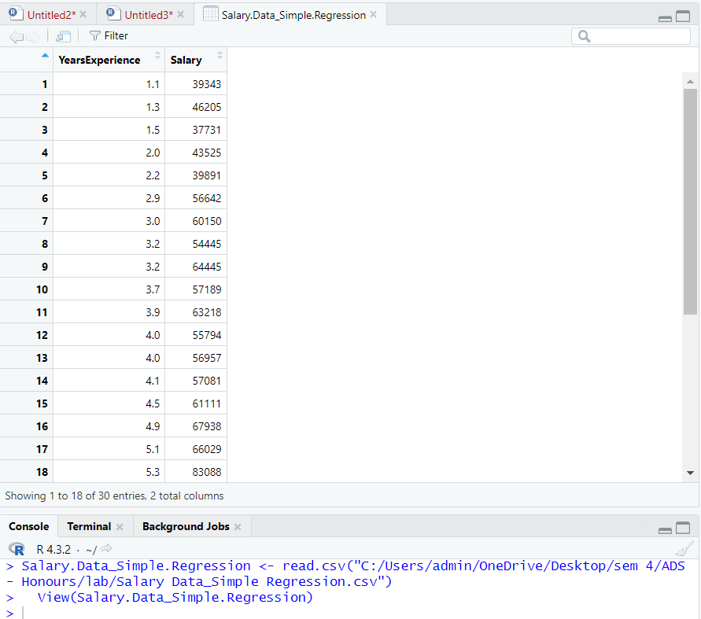

**summary() –**

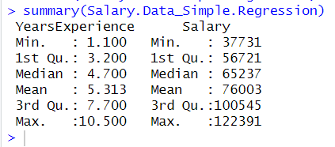

**Checking whether dependent variable, Salary, follows normal distribution –**

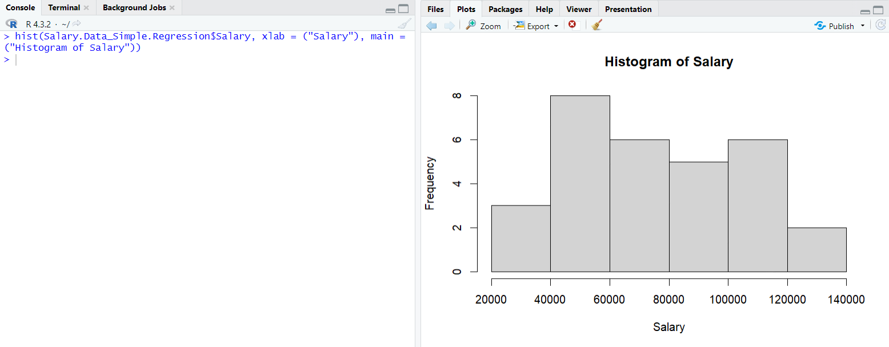

**Checking if the independent and dependent variables, Years of Experience and Salary, follow a linear relationship –**

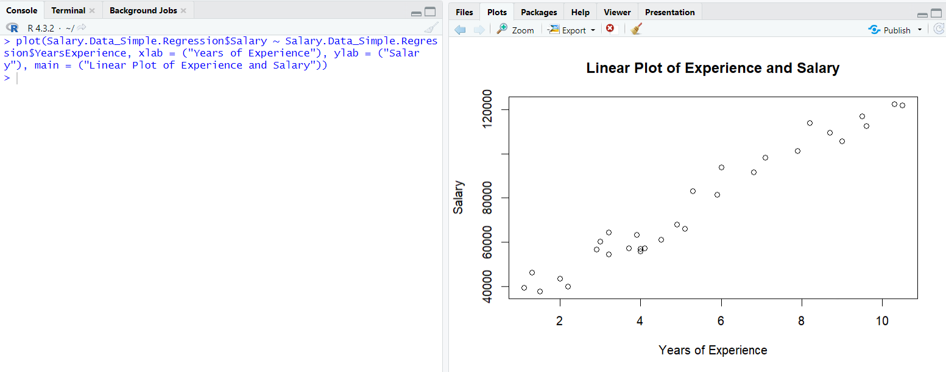

**Simple linear regression analysis –**

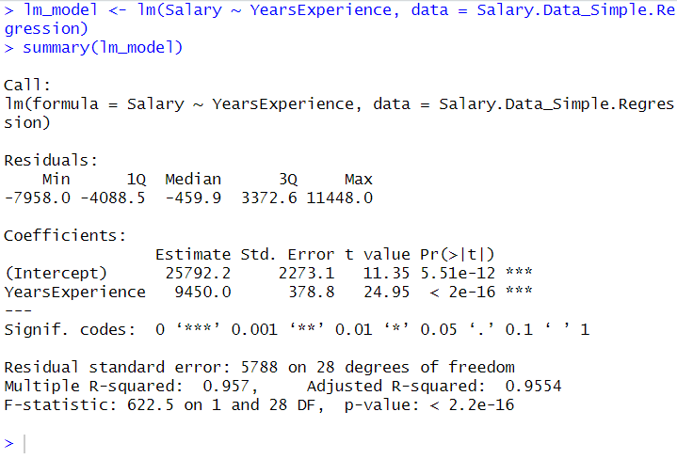

**Checking for homoscedasticity –**

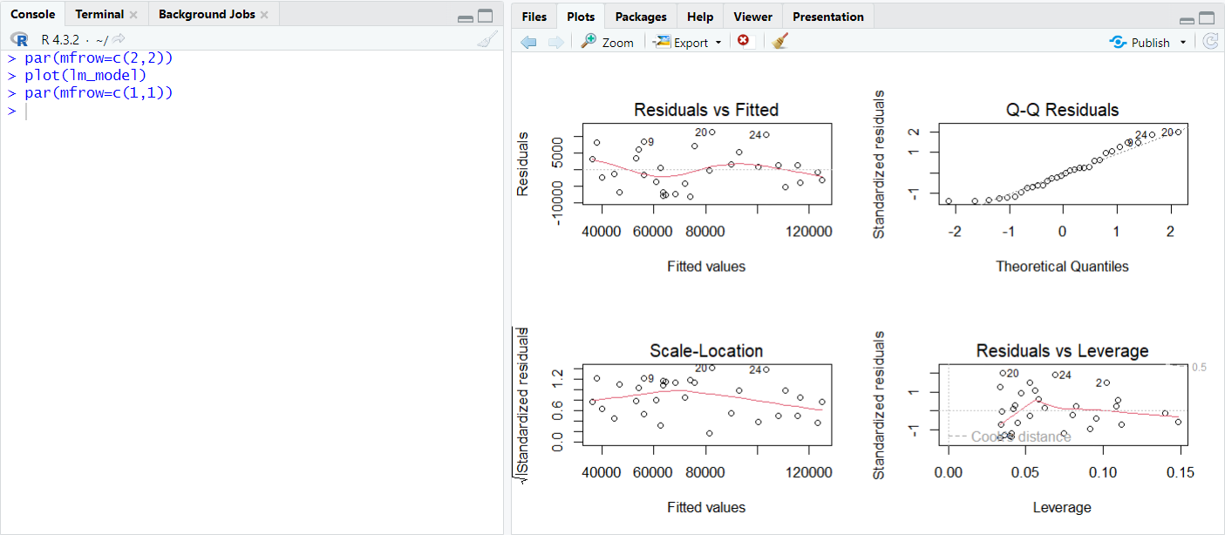

**Visualizing the results with graphs –**

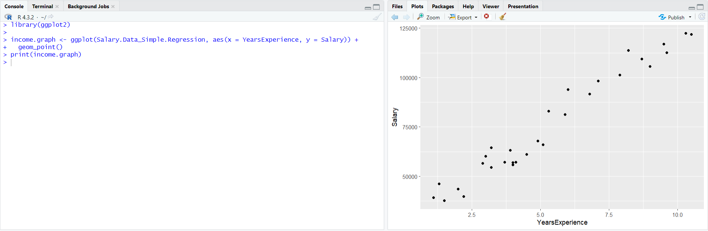

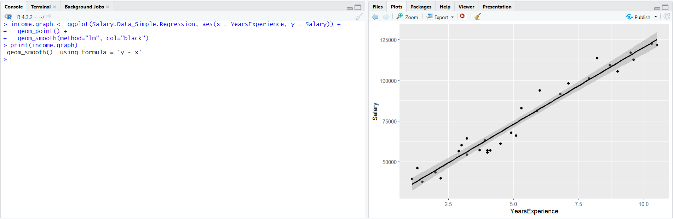

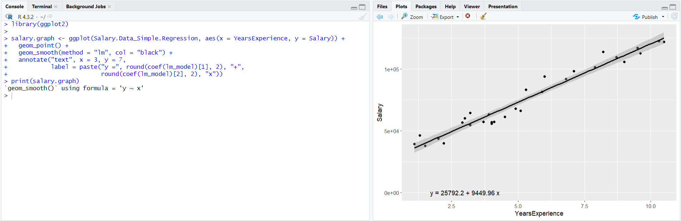

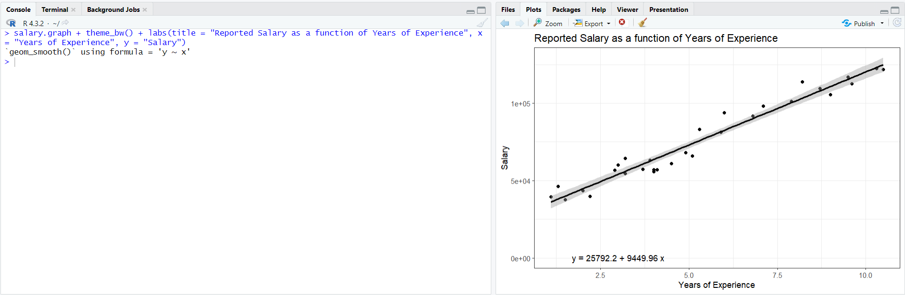

**Final graph –**

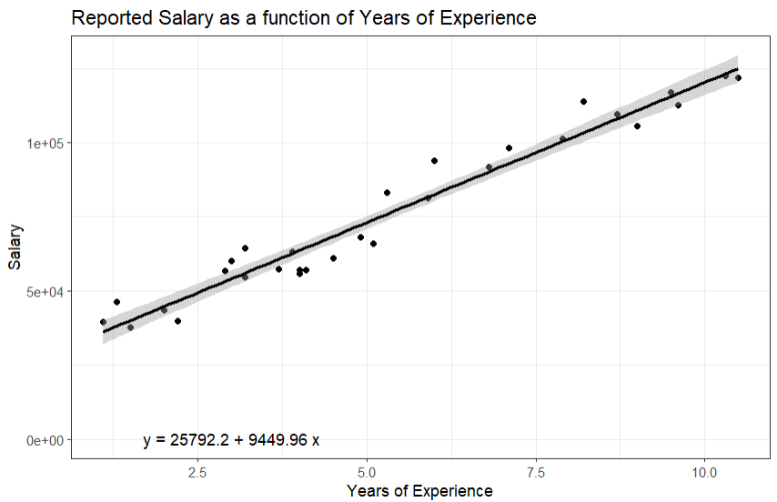

**MULTIPLE REGRESSION**

**Rcode implementation –**

MultipleRegression <- read.csv("C:/Users/admin/OneDrive/Desktop/sem 4/ADS - Honours/lab/Multiple Regression.csv")

View(MultipleRegression)

summary(MultipleRegression)

# independent variables (age, experience) and dependent variable (income)

cor(MultipleRegression$age, MultipleRegression$experience)

hist(MultipleRegression$income, xlab = "Income", main = "Histogram of Income")

plot(MultipleRegression$experience ~ MultipleRegression$age, xlab = "experience", ylab = "age", main = "age vs experience")

model.lm<-lm(income ~ age + experience, data = MultipleRegression)

summary(model.lm)

par(mfrow=c(2,2))

plot(model.lm)

par(mfrow=c(1,1))

plotting.data <- expand.grid(age = seq(min(MultipleRegression$age), max(MultipleRegression$age), length.out=30), experience = c(min(MultipleRegression$experience), mean(MultipleRegression$experience), max(MultipleRegression$experience)))

plotting.data$predicted.y <- predict.lm(model.lm, newdata = plotting.data)

plotting.data$experience <- round(plotting.data$experience, digits = 2)

plotting.data$experience <- as.factor(plotting.data$experience)

income.plot <- ggplot(MultipleRegression, aes(x = age, y = income)) + geom_point()

income.plot

income.plot <- income.plot + geom_line(data = plotting.data, aes(x = age, y = predicted.y, color = experience), linewidth = 1.25)

income.plot

income.plot <- income.plot + theme_bw() + labs(title = "Income as a function of Age and Experience", x = "Age", y = "Income", color = "experience")

income.plot

**Importing dataset –**

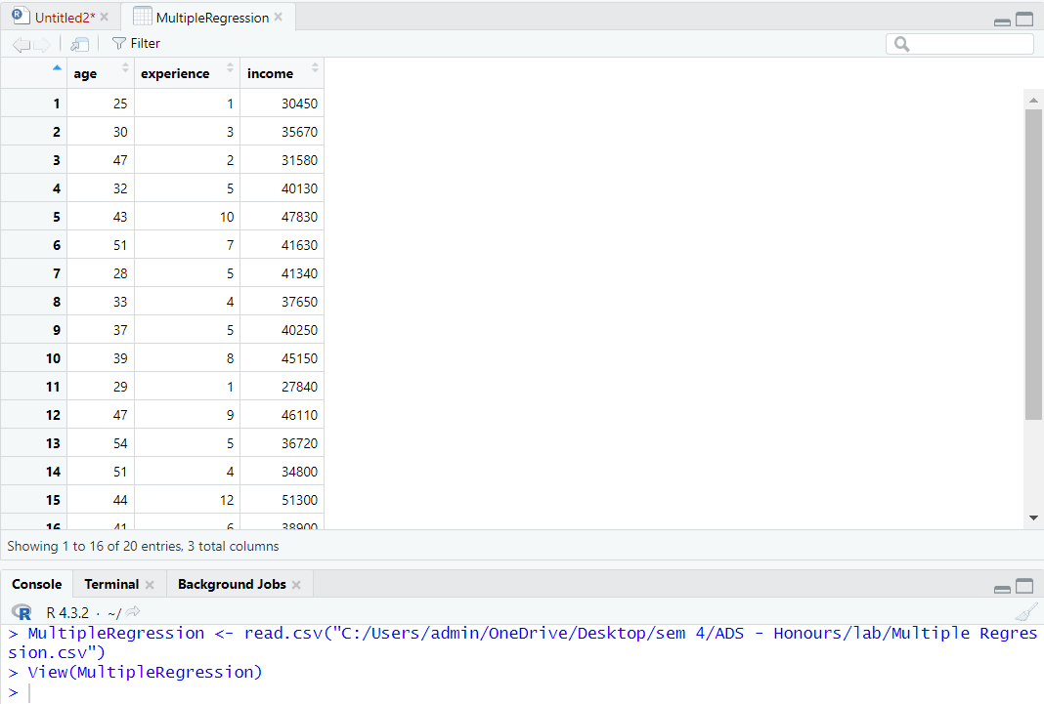

**summary() –**

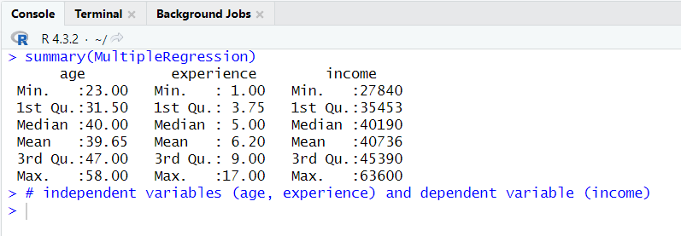

**Using cor() to test independent variables aren’t too highly correlated –**

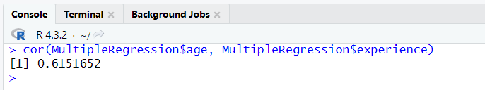

**Using hist() to test if dependent variable (income) follows normal distribution –**

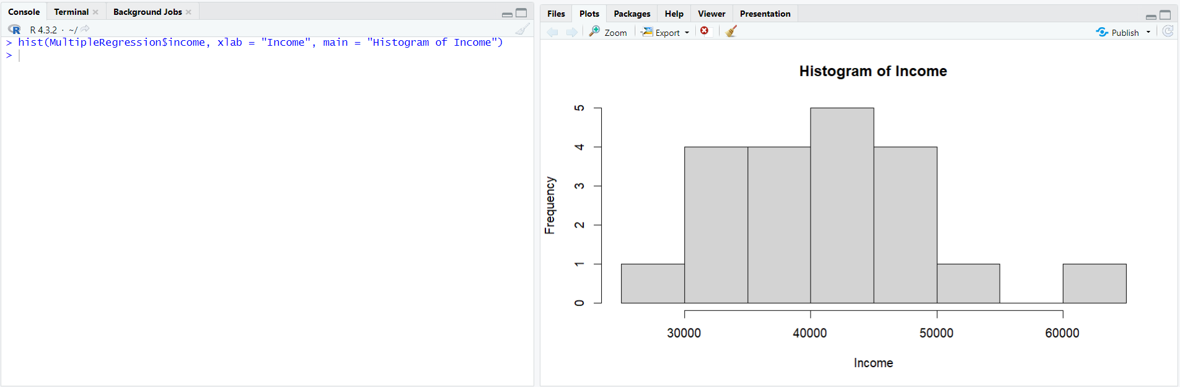

**Checking linearity for age and experience –**

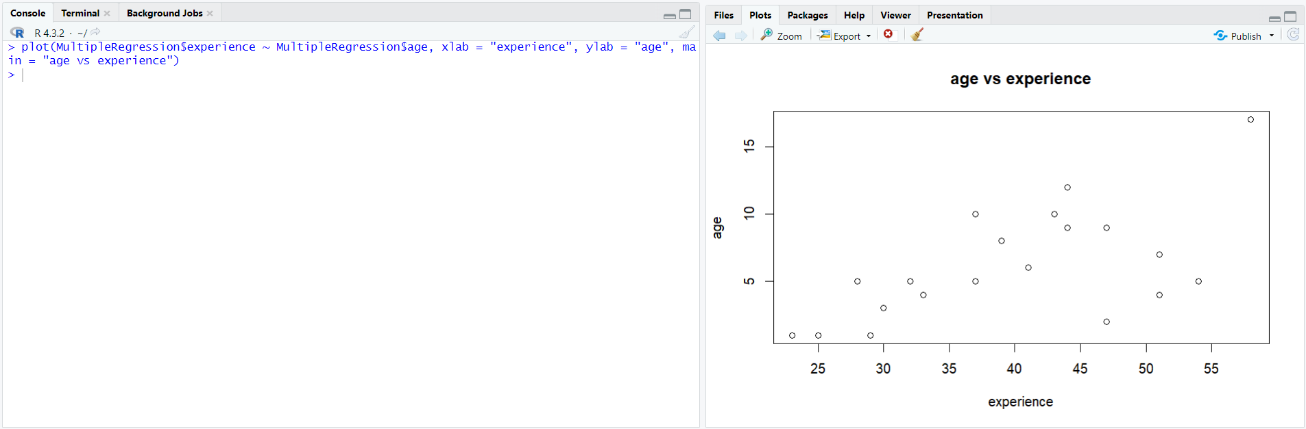

**Fitting linear model with income as the dependent variable and age and experience as the independent variables**

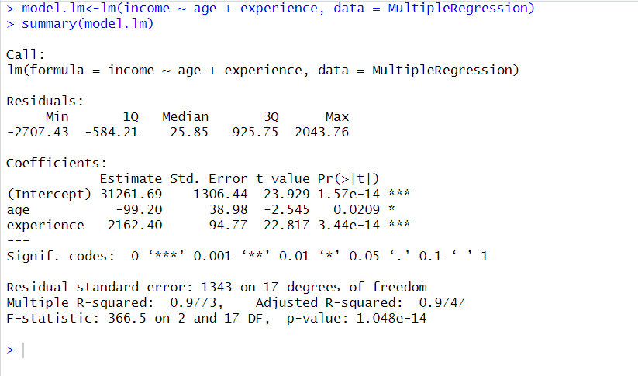

**Checking for Homoscedasticity –**

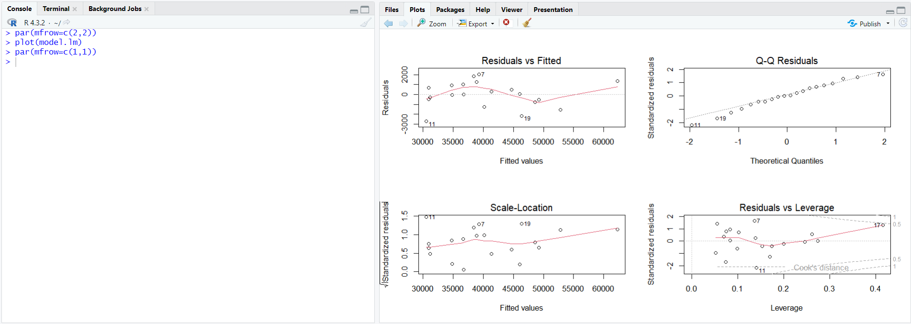

**Making a dataframe for plotting data (Visualizing with a graph) –**

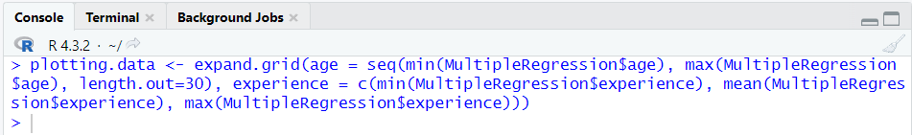

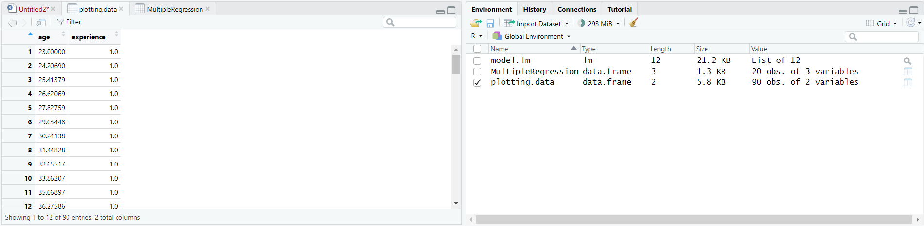

**Predicting values for income, rounding age, and changing ‘age’ variable into a factor –**

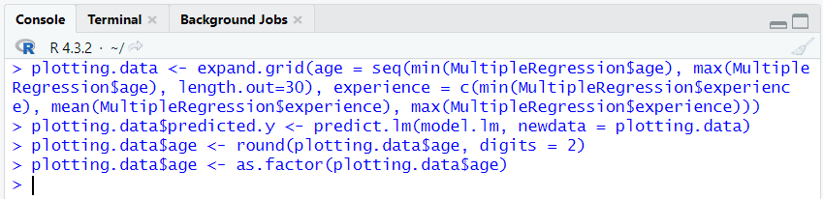

**Plotting the original data –**

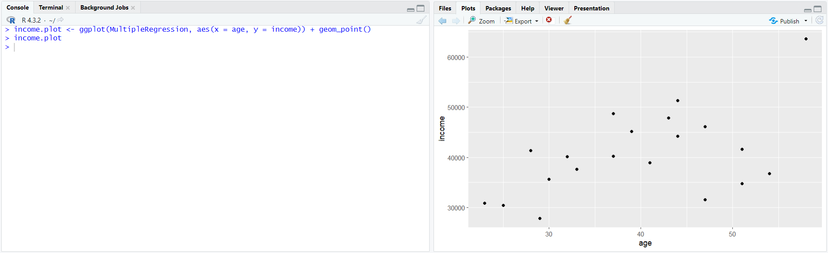

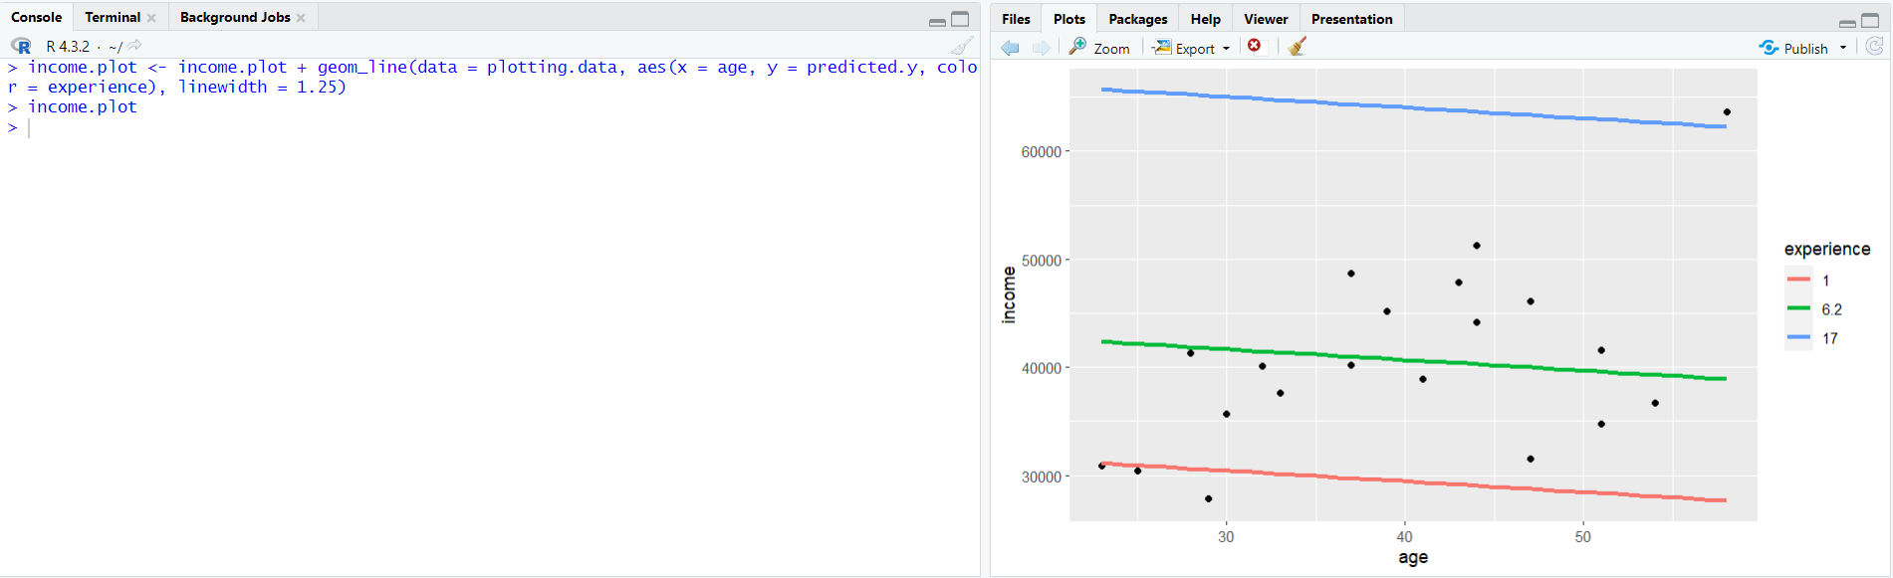

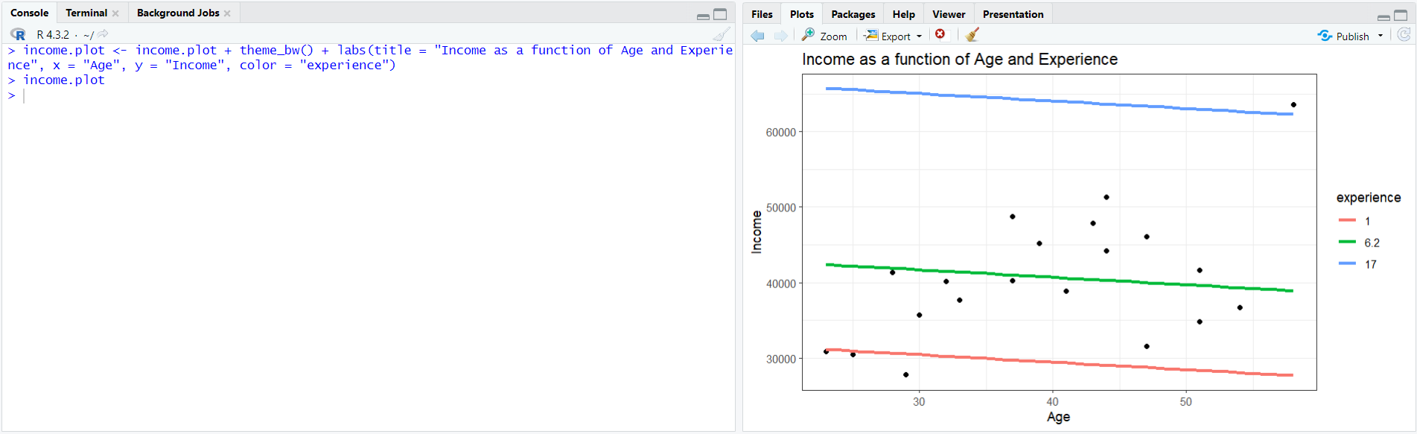

**Final Graph –**

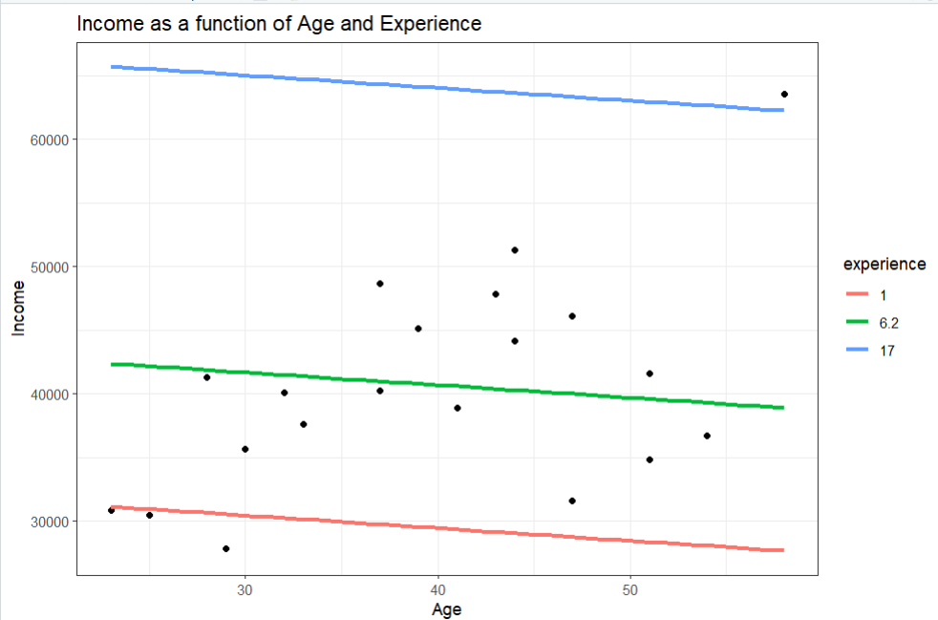

**______________________________________________________________________**

**Conclusion:**

In our experiment conducted in RStudio, we plotted graphs for simple regression and multiple regression. The visualizations revealed clear trends in the relationships between our variables, providing valuable insights into the predictive power of each model.

**Post lab:**

1. **Based on the image given below, a model was built with an objective to predict the salary of an individual based on the years of experience. From the given output, what does the p-value indicate with respect to hypothesis testing?**

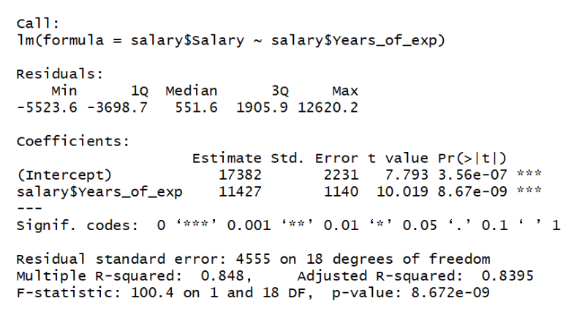

**Select ones which are appropriate:**

1. **The model failed to reject the null hypothesis**
2. **There is strong evidence of a relationship between salary and years of experience**
3. **There is strong evidence that there is no relationship between salary and years of experience**
4. **The null hypothesis can be rejected**

Read the dataset [auto.csv](https://drive.google.com/file/d/1sh2EhMzcMezF_BwPhXT-nmy52G-l35BB/view?usp=sharing) and answer the questions 2 to 4 based on the same. The dataset contains the weight and fuel consumption details of different cars.

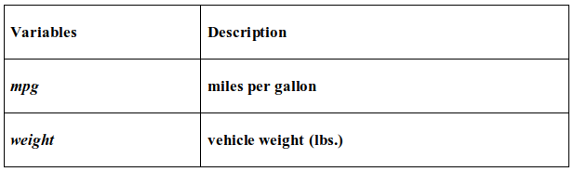

The objective of the problem is to predict mpg (miles per gallon) using weight of the vehicle.

1. **The adjusted R2 for the linear model is ___**
2. **0.87**
3. **0.77**
4. **0.97**
5. **None of the above**
6. **The third quartile residual value for the linear model built is ___**
7. **-1.91**
8. **-7.21**
9. **-0.08**
10. **1.73**
11. **The t value corresponding to the coefficient of weight is ___**
12. **62.77**
13. **-31.71**
14. **40.56**
15. **None of the above**
16. **Standardized residuals have:**
17. **binomial distribution with n degrees of freedom**
18. **t distribution with n-2 degrees of freedom**
19. **log-normal distribution with n-2 degrees of freedom**
20. **chi-square distribution with n degrees of freedom**
21. **The higher the value of R for a model, the observations are more closely grouped around:**
22. **the origin**
23. **the best fit line**
24. **average values of the predicted variable**
25. **the intercept**
26. **Which of the following metrics can be used for evaluating regression models?**

* **R Squared**
* **Adjusted R Squared**
* **F Statistics**
* **RMSE / MSE / MAE**

1. **All**
2. **None**
3. **I, IV**
4. **I, II, III**